Old version we have save as copy available.. joomla 3

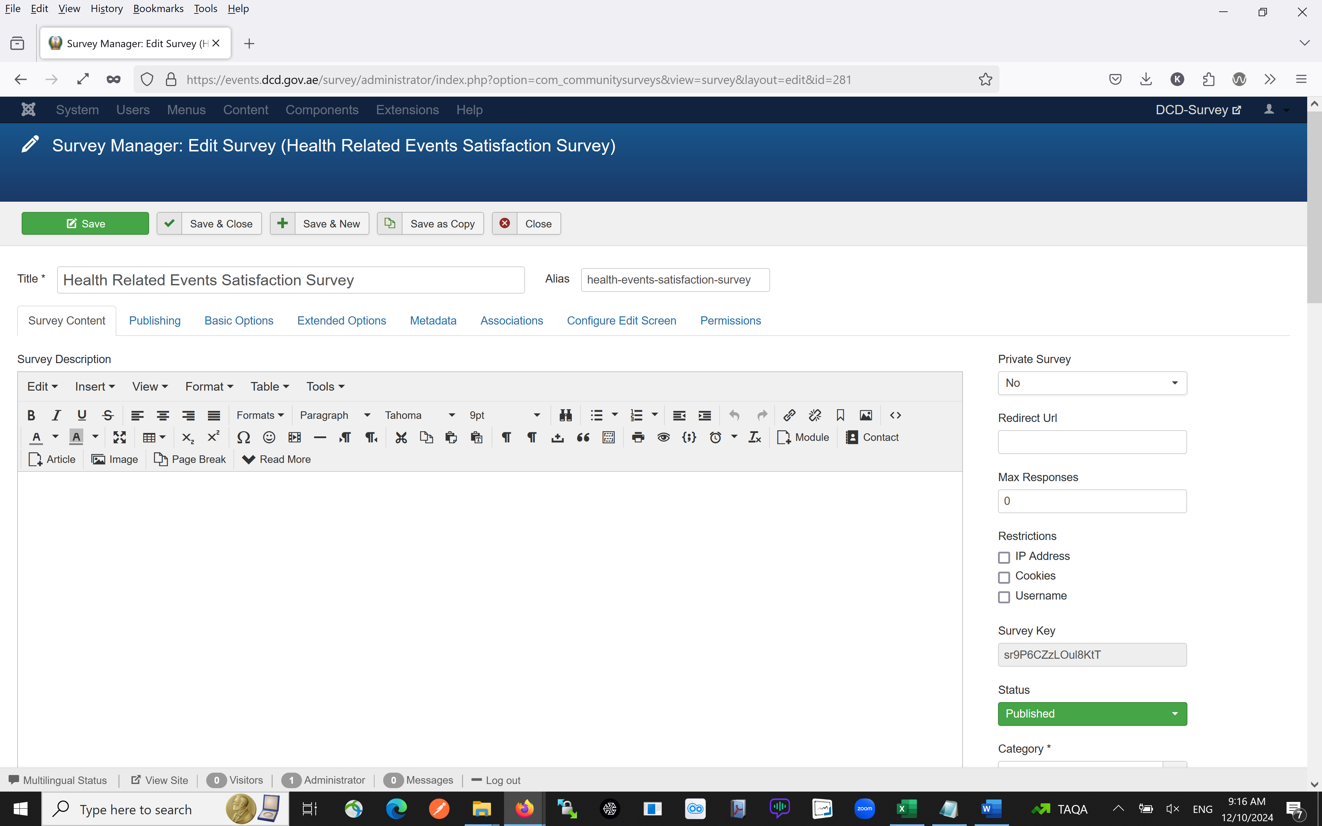

Now in joomla 5 new version we donto have this option to save a copy..

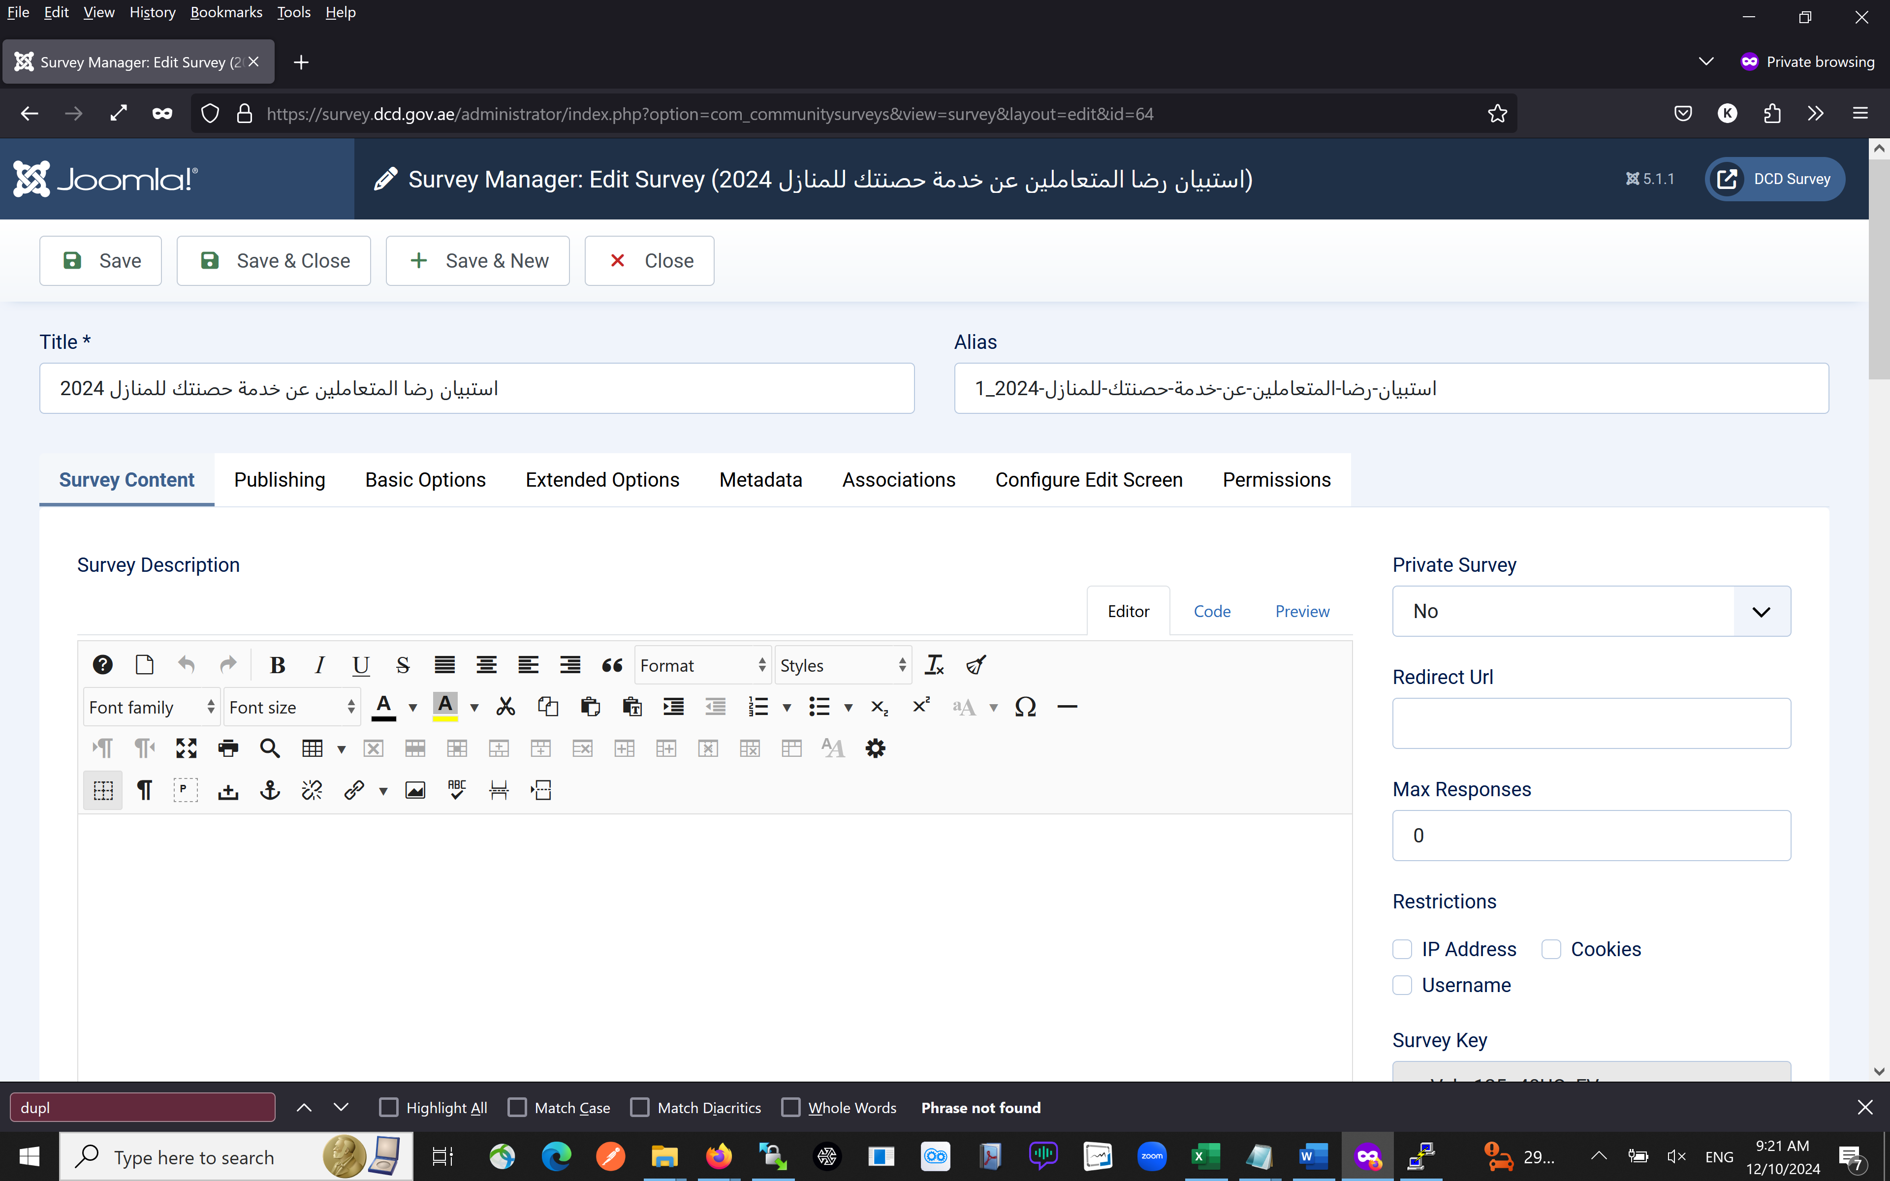

Kindly help in solve this problem..